**Use Case: Convert Temperature**

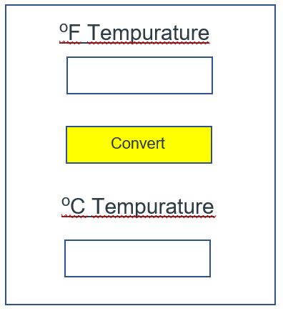Step 1: Open application to show screen

****Step 2: Input temperature in Fahrenheit you want to convert

32

****Step 3: Click/press the “Convert” button

32

****Step 4: View the desired temperature in Celsius

0

32